Robot Fingers

Subject:  Related Subjects: | Grade Level(s):  Length of Lesson: | Type: Inquiry / Design / Project  Keywords: Degree of freedom, pitch, yaw, roll, prosthetic

Lesson Overview
Use this section to describe at a high level what the lesson is. Should be no more than 3-4 lines.

Lesson Focus
Students will create a robot hand with finger and thumb that touch and separate. Both appendages will move but will not be able to bend.

Lesson Objective(s) | - Students wire 1.5v motors to turn in the forward and reverse direction  - Students construct base to allow appendages to move toward and away from each other  - Students create stop to prevent hyperextension (bending back) of appendages in the away direction.

Lesson Timing

5 minutes | Introduce the Lesson
30 minutes | ...

Materials | - –2 DPDT (six lead)switches  - –Insulated wire  - –2 1.5v motors  - –Wire strippers  - –Glue gun  - –Glue sticks  - –Utility knife  - –Foam board  - –Craft sticks, coffee stirrers, or Popsicle sticks  - –1/4” Dowel  - –Drill  - –Sharpened pencil  - –3/16th inch drill bits  - –Masking tape  - –Goggles  - –Saw  - –AA Battery holder  - –2 AA batteries
Instructor Prep | - Step 1
Related Resources | - List related lessons/ppts etc available from USC or outside, trusted orgs

Lesson Plan

Introduction

Robots and prosthetic devices are fast becoming a part of our society. Creating these marvels of science require a lot of thought, innovation and engineering. Simple movements that humans take for granted require complex calculations and lots of components to implement in a robot. Consider taking one step forward

- Brain decides to move left leg
- Body weight shifts to right leg
- Left leg is lifted
- Left leg is swung forward
- Weight is shifted toward left leg
- Left leg touches ground
- Weight is balanced between two legs

Countless numbers of nerves and muscles work in concert to make it happen. When you add in the brain for determining a safe place to place leg, and eyes for placement of leg, the number of calculations increases even further.

Artificial implementation of movement for robots or artificial limbs is tremendously complicated and costly in terms of space and resources

The complexity of creating artificial limbs is not obvious. For every motion a control signal must be sent. Simply moving a limb from one place to another requires a signal, a way to carry the signal and way to move the limb. In our bodies, the brain creates the signal, the nerve carries the signal and the muscle moves the limb. Each direction the limb moves is a degree of freedom. Your shoulder gives your arm three degrees of freedom: up/down (pitch), right/left (yaw) and rotating (roll). Your elbow gives your forearm 1 degree of freedom: pitch.

In creating the robot fingers, you will be the brain and eyes because the robot fingers cannot operate on their own. You will decide when to move it and if it is moving the correct way. The switch will be and extension of the decision maker (your brain). The wires will be the nerves. Electricity will be the nerve impulses. The motors will be the muscle. The craft sticks will be the finger and thumb, respectively.

Notice when you move your real finger and thumb together you can control speed that the close and the pressure applied. If we were to do this with the robot fingers, we would have to add variable speed motors and pressure sensors.

.

Procedure
- –Cut and strip 4 pieces of wire
- –Strip the wires of a battery holder.
- –Twist ends of two wires and solder to one lead of motor.
- –Twist ends of remaining two wires and solder to second lead of motor.
- –Solder the one wire of twisted pair from one motor lead to top lead of switch on one side.
- –Solder the other wire of 1st twisted pair from the motor lead to bottom lead of switch on other side.
- –Solder the one wire of other twisted pair from 2nd motor lead to top lead of switch on the unoccupied side.
- –Solder the other wire of twisted pair from 2nd motor lead to bottom lead of switch on other, unoccupied side.
- –Solder red wire of battery holders wires to middle lead of switch.
- –Solder black wire of battery holders wires to middle lead of switch on other side (figure 1).
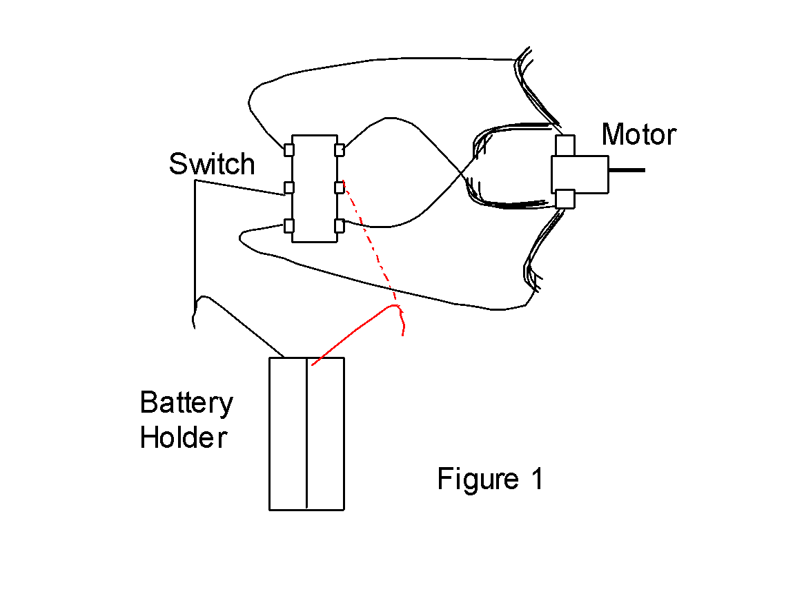
- –Test circuit with batteries.
- –Connect a wire from the middle posts of 1st switch to middle posts of the second switch
- Repeat steps 1 through 11 for a second motor (except for the steps with the battery holder. With this method, instead of using a separate battery holder you are using the same battery holder.
- –Measure and cut 2 - 2”x 6”foam board strips
- –Glue the middle of the flat side of one strip to the top of the edge of the other strip.

- –Make 2 holes in the sides of the flat strip

- –Cut 2 - ½” dowels
- –Drill holes in the center of each dowel
- –Glue a craft stick to the side of 1 dowel

- –Glue a different craft stick to the side of the other dowel
- –Glue motors to side of foam board side strip with leads facing out

Top

Side

- –While carefully arranging wires, push top of switch for each motor through hole in flat strip on its corresponding side.
- –Glue battery holder to the middle of flat strip

- –Break 1 craft stick in half
- –Glue ½ craft sticks to back corner of each motor to serve as a stop

- –Insert dowels with craft sticks into each motor so that they swing together and touch and swing back and are stopped by back stop

- –Orient switches so that forward closes arms and back opens arms

Wrap-up
End the lesson with some final discussions about what students designed/discovered. Connect their activity back to the focus question/problem, real world examples, and STEM careers.

Also include notes about any special cleanup considerations

Lesson Background for Teachers

Suggested Real-World STEM Connections
- List possible related Role Models in STEM (with details and links to more reading). Give suggestions for examples of scientists/engineers who are from underrepresented groups in STEM in related careers.
- List related real-world engineering problems and examples

Lesson Variations and Options
Include descriptions of alternative methods or ways to present things.

Explanation

The complexity of creating artificial limbs is not obvious. For every motion a control signal must be sent. Simply moving a limb from one place to another requires a signal, a way to carry the signal and way to move the limb. In our bodies, the brain creates the signal, the nerve carries the signal and the muscle moves the limb. Each direction the limb moves is a degree of freedom. Your shoulder gives your arm three degrees of freedom: up/down (pitch), right/left (yaw) and rotating (roll). Your elbow gives your forearm 1 degree of freedom: pitch.

In creating the robot fingers, you will be the brain and eyes because the robot fingers cannot operate on their own own. You will decide when to move it and if it is moving the correct way. The switch will be and extension of the decision maker (your brain). The wires will be the nerves. Electricity will be the nerve impulses. The motors will be the muscle. The craft sticks will be the finger and thumb, respectively.

Notice when you move your real finger and thumb together you can control speed that the close and the pressure applied. If we were to do this with the robot fingers, we would have to add variable speed motors and pressure sensors.

Key Concepts and Vocabulary
- Word 1: Grade Appropriate Definition
- Word 2: Grade Appropriate Definition

Safety Notes
- Students should use protective eyewear when using drill
- Student should exercise caution with glue gun
- Student should exercise caution with utility knife

